Please find our comments in BLUE color
Background

Realsport 101 are an online sport website which covers all the major sports. All the writers are volunteers and the company is not funded by adverts

We wil be using JomSocial to manage the writers and their profiles. This will also interlink with K2 and we will let JomSocial handle the K2 profiles.
Comment: Currently under which user group the writers fall?
We will not be using the social media aspect of JomSocial at the moment but we maybe in the future.

Here are the changes we need to make

- When logged in, the we would like the setting’s cog moved to the menu on the left

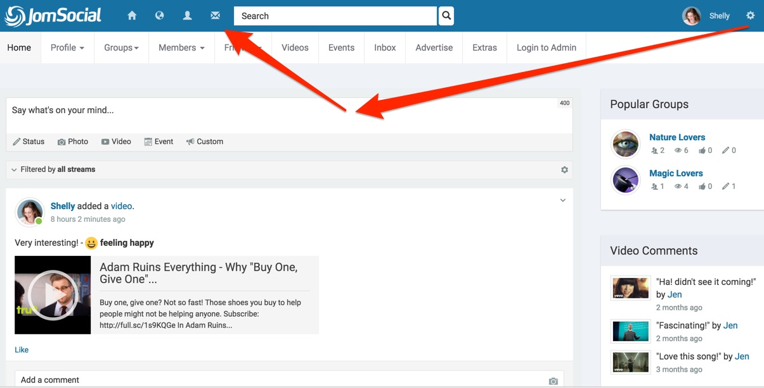

we just want to ensure that you want to develop a Jomsocial tool bar so that it appears always at top of every page regardless of it's jomsocial component.

Comment: We see right now, you don’t have Jomsocial installed. So just to summarize the things that we need to install Jomsocial and want the menu like the above screen shot. The look and feel and typo graphy would be same as our website. In case writter logs in, what about the existing menu shown in website ? Will it be the same place as shown right now?
I’m redirected to home page when I try to access https://realsport101.com/staging3/administrator It would be appreicated if you provide us backend login URL and details?

2. We would like Social media icons added to the profile page. The user will be able to put in their own links in the edit social profile page. They would appear as in the image on the left bottom of the picture. If the use does not have (for example) a YouTube link to put in, the icon will not display
Comment: Ok, for icons we need to have some CSS so those icons visible but when ever you want to introduce more social media urls then you need to take developer’s help to make some CSS. I hope that is fine with you.
On the left hand side next to the profile picture, we would like ‘total number of reads and total number of article’s posted on K2. K2 already provides these numbers on the current set up we have so it should just be a case of plucking the numbers from the database ad displaying them.
Comment: Is “Total number of reads”based on profile visits done by other users?

Under about me, the writer profile page should display the latest articles from the author (maybe K2/jomSocial integration already does this

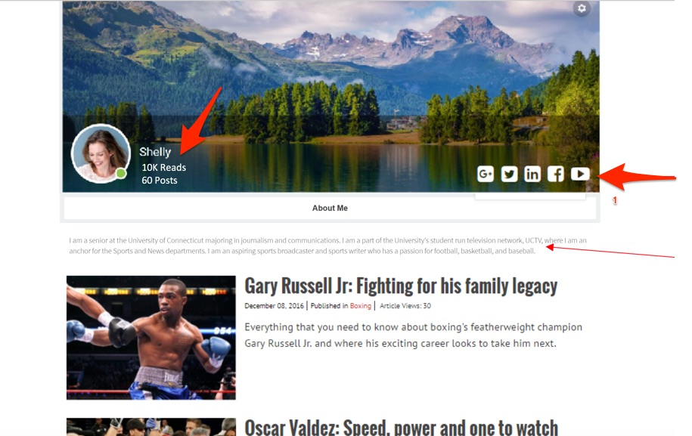

Comment: We can have list of articles by respective profile user with help of third party extension https://www.minitek.gr/joomla-extensions/jomsocial-k2-integration We might need to change look and feel as per needs. The above list view of articles is fine with you? When we start work, we want you to provide the above extension.
3. The edit profile button in the top left should bring up the profile edit page. On the right hand side of that page we would like to remove the ‘privacy’ buttons and set the privacy ourselves. I will let you know which way they need setting.
Comment: Ok, please let us know more about the way they need setting?
4. we would like to remove the option of the writer setting a vanity URL. (can this already be done?)
Comment: Ok, may I know where you see the option in current website?
5. We would like the following (if JomSocial does not already do it)

•Username and name (only allowed to be changed by admin)
•Remove font end language
•Remove DTS offset
•Passwords for users to be managed here.

Comment: For “Username and name”, do you mean to say that via front end, the logged in user should be edit only rest fields in Jomsocial profile? We understand for front end language and DTS field. Can you explain “Passwords for users to be managed here.”?

